European Semester 2015/2016 country fiche on disability
Bulgaria | 
Report prepared by:
Kapka Panayotova
Maria Dimitrova

With comparative data provided by the ANED core team

The Academic Network of European Disability experts (ANED) was established by the European Commission in 2008 to provide scientific support and advice for its disability policy Unit. In particular, the activities of the Network support the development of the European Disability Strategy 2010-2020 and practical implementation of the United Nations Convention on the Rights of Disabled People in the EU.

This country report has been prepared as input for the European Semester from a disability perspective.

Note:
The statistics provided in October 2015 are based on the EU-SILC 2013. This is the most recent micro data available to researchers for analysis from Eurostat. This report may be updated as new data becomes available.



Table of contents

1 Summary of the overall situation and challenges 2
2 Assessment of the situation of disabled people with respect to the Europe 2020 headline targets 4
2.1 Strategic targets 4
2.1.1 A note on the use of EU data 5
2.2 Employment data 7
2.2.1 Unemployment 9
2.2.2 Economic activity 11
2.3 Education data 13
2.3.1 Early school leavers 13
2.3.2 Tertiary education 15
2.4 Poverty and social exclusion data 16
3 Description of the situation and trends in relation to each target area 20
3.1 Employment 20
3.2 Education 21
3.3 Poverty and social inclusion 22
4 Assessment of policies in place to meet the relevant headline targets 24
4.1 Employment 24
4.2 Education 24
4.3 Poverty and social inclusion 24
4.4 Synergies between developments in the different areas 25
5 Review of the European Semester from a disability perspective 26
5.1 Progress on disability-specific Country Specific Recommendations (CSRs) 26
5.2 Progress on other CSRs from a disability perspective 26
5.3 Assessment of disability issues in the Country Report (CR) 27
6 Assessment of the structural funds ESIF 2014-2020 or other relevant funds in relation to disability challenges 28
7 Recommendations 32

Summary of the overall situation and challenges

Bulgarian disability policies remain far from being inclusive despite the UN Convention on the Rights of Persons with Disabilities (UN CRPD) ratification back in 2012.

Scarce data available to the public show that in terms of economic activity and employment rates disabled Bulgarians are not much behind the EU average. It is, however, possible that many people with complex support needs are not accounted for in such statistics – they are considered retired because of having a disability pension, regardless of their age. A request under the Access to Public Information Act addressed to the Employment Agency failed to show the age, gender or impairment structure of the active disabled population, as well as of disabled job-seekers.

There is no evidence of individual supports provided to disabled people, which in combination with lack of accessibility make these statistics doubtful. In addition, this data does not include disabled people in residential care, whose number is also significant and growing – in large settings or small group homes. Technical aids are outdated and assistance is provided on a year-by-year project basis. This makes many people with complex support needs apply for residential placement or home care.

Education levels reported for disabled people are low and no data is available on early school leavers due to disability. However, the result is demonstrated through high unemployment rates and strong dependence on social welfare, i.e. remarkable poverty among disabled population (see Table 17 below).

Disability status is still provided on the basis of diagnosis with no individual assessment of the needs for social inclusion and participation. Thus over 800,000 people receive disability pensions, disability allowances and welfare benefits that are below the level of a basic income.

Current deinstitutionalisation policies – for both children and adults with disabilities – provide for care in small group homes (SGH), which does not change significantly the quality of life that disabled people live. SGH residents are often not in control of their daily activities, empowered or offered opportunities to move to community arrangements; and managed as in residential institutions.

This situation calls for fundamental reform in disability policies but also for serious changes in the provision of mainstream public services, such as transport, healthcare, education, etc., which have to become more inclusive and serve disabled people on equal basis as all other citizens. Accessible and affordable housing, along with better quality technical aids and personal assistance, may compensate the disability related deficits on a personal level. Inclusive education and employment policies should encourage schools and open labour market to accommodate the needs of disabled people. Peer support may further contribute to the self-esteem and self-confidence of disabled people thus opening opportunities for fulfilling life paths.
New disability legislation with a strengthened Agency for Disabled People can work towards this end, as well as inclusive design of all training and employment programmes funded by national and EU sources.

Assessment of the situation of disabled people with respect to the Europe 2020 headline targets

Strategic targets

Table 1: Europe 2020 and agreed national targets for the general population
 | Europe 2020 targets | National targets
Employment | 75% of the 20-64 year-olds to be employed | 76%
Education | Reducing the rates of early school leaving below 10% | 11%
Education | At least 40% of 30-34–year-olds completing third level education | 36%
Fighting poverty and social exclusion | At least 20 million fewer people in or at risk of poverty and social exclusion | 260,000 (persons living in monetary poverty)

Relevant disability targets from national strategies or sources:
Most of the disability related policy documents (strategies and action plans) do not contain specific targets – quantitative or qualitative. Numbers report accomplishments and do not engage the Government with future targets as far as people with disabilities are concerned. These include:

- Strategy for Equal Opportunities for Disabled People 2008 – 2015 http://www.strategy.bg/StrategicDocuments/View.aspx?lang=bg-BG&Id=445 (last check on 17 October 2015).
- Action Plan on Equal Opportunities for Disabled People 2014 – 2015 http://www.strategy.bg/FileHandler.ashx?fileId=4460 (last check on 17 October 2015).
- 2014 Annual Report on the Implementation of the Action Plan on Equal Opportunities for Disabled People in the period 2014 – 2015 http://www.strategy.bg/FileHandler.ashx?fileId=5614 (last check on 17 October 2015).
- Long-term Strategy on Employment of Disabled people (2011 – 2020) http://www.strategy.bg/FileHandler.ashx?fileId=1652 (last check on 17 October 2015).
- Action Plan on Implementation of the Long-Term Strategy on Employment of Disabled People (2011 – 2020) for the period 2014 – 2015 http://www.strategy.bg/FileHandler.ashx?fileId=4759 (last check on 17 October 2015).
- Action Plan on Implementation of the UN Convention on the Rights of Persons with Disabilities (2015 – 2020) passed by the Council of Ministers on the 25th June 2015 http://www.mlsp.government.bg/ckfinder/userfiles/files/dokumenti/drugi/Plan%20CRPD%202015%202020.pdf (last check on 17 October 2015).
- Report on the Implementation of the Action Plan with Measures to Harmonise the Bulgarian Legislation and Policies with the UN CRPD http://www.strategy.bg/FileHandler.ashx?fileId=5615 (last check on 17 October 2015).
- Review of the Disability Pensions in the Years 2000 – 2014 http://www.noi.bg/images/bg/about/statisticsandanalysis/analysis/Analiz_pensii_Inv_2000-2014.pdf (last check on 17 October 2015).

A note on the use of EU data

Unless specified, the summary statistics presented in this report are drawn from 2013 EU-SILC micro data. The EU-SILC sample includes people living in private households and does not include people living in institutions. The proxy used to identify people with disabilities (impairments) is whether ‘for at least the past 6 months’ the respondent reports that they have been ‘limited because of a health problem in activities people usually do’. Responses to this question vary between countries and national data sources are added for comparison, where available.

Table 2: Self-reported ‘activity limitations’ as a proxy for impairment/disability (EU-SILC 2013)
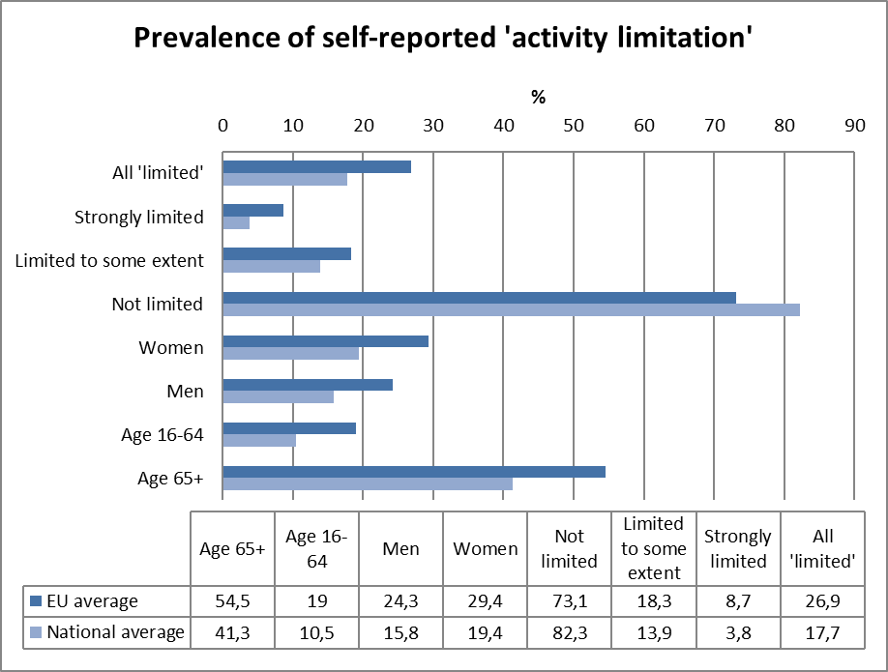
Source: EUSILC UDB 2013 – version 2 of August 2015
It is relevant to observe that Bulgarian estimates of impairment prevalence fall below the EU average, which may affect national estimations of equality gaps.

In subsequent tables, these data are used as a proxy to estimate ‘disability’ equality in the main target areas for EU2020 – employment, education and poverty risk. The tables are presented by disaggregating the estimated proportion of people who report and do not report limitations for each indicator (e.g. among those who are employed, unemployed, at risk of poverty, etc.).

Employment data

Table 3: Most recent employment data, aged 20-64
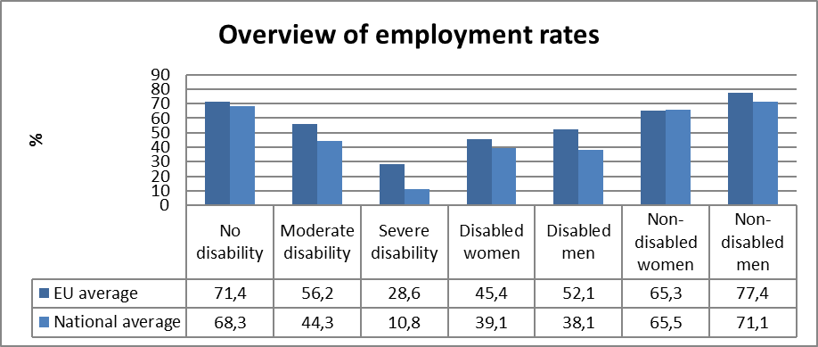
Source: EUSILC UDB 2013 – version 2 of August 2015

Table 4: Employment rate data, by age group
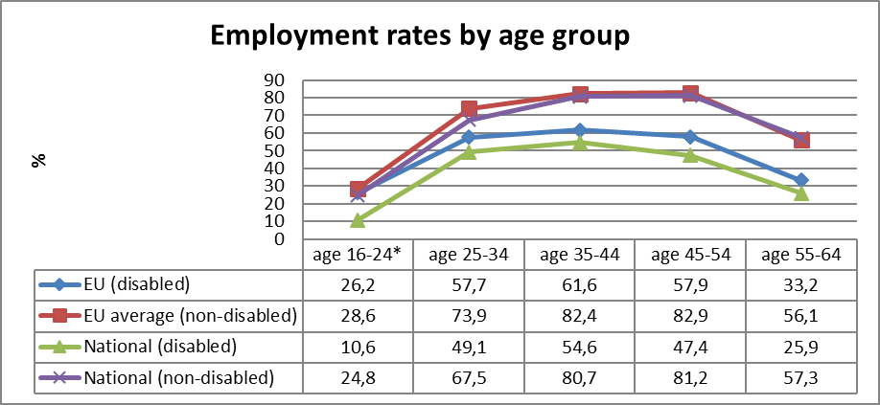
Source: EUSILC UDB 2013 – version 2 of August 2015
* In Bulgaria there are fewer than 50 observations in the sample of people aged 16-24 who declare impairment/limitation. These data should be treated with caution.
Table 5: Trends in employment by gender and disability (aged 20-64)
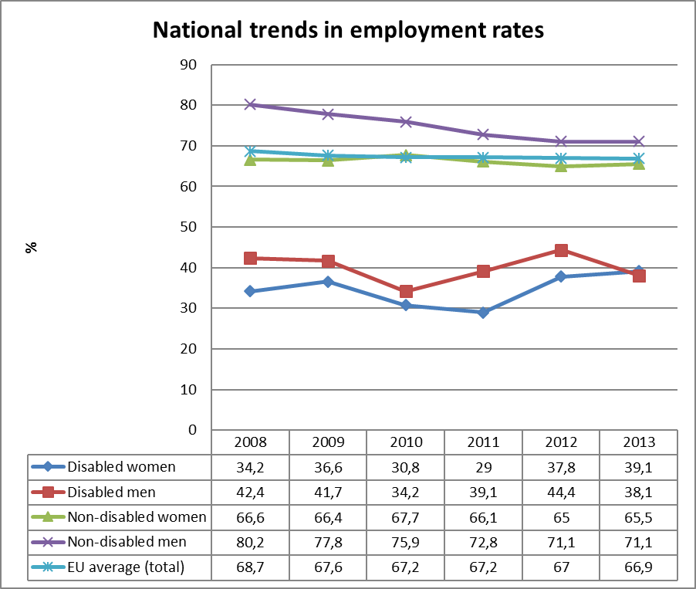
Source: EUSILC UDB 2013 – version 2 of August 2015 (and preceding UDBs)

The table above shows a comparison of national employment trends for disabled and non-disabled women and men, and compares this with the EU2020 headline indicator for the EU as a whole.

Alternative data on disability and employment provided by the national expert:

The only disability-related data on employment is contained in the 2014 Annual Review of the Employment Agency. The analysis of general employment – unemployment statistics by age, gender, geography, etc. - does not include disability as a factor. There is a statement however that “increase of unemployment rates is registered among disabled people” (p. 31).

The above document also reports that the number of unemployed disabled people involved in the Operational Programmes is 892, which is 0,7% of the overall number of participants, which is by 1,5 percentage point less than the previous year. There were also disability earmarked measures under the Employment Promotion Act, which resulted in average monthly employment of 2.258 people, which is 9,4% of all beneficiaries participating in programmes and measures under the law.

Unemployment

National administrative rules and definitions of ‘unemployment’ vary, and these may affect the way in which disabled people are categorised in different countries. The following tables compare national data with the EU2020 headline indicator for the EU.

Table 6: Most recent unemployment data, aged 20-64
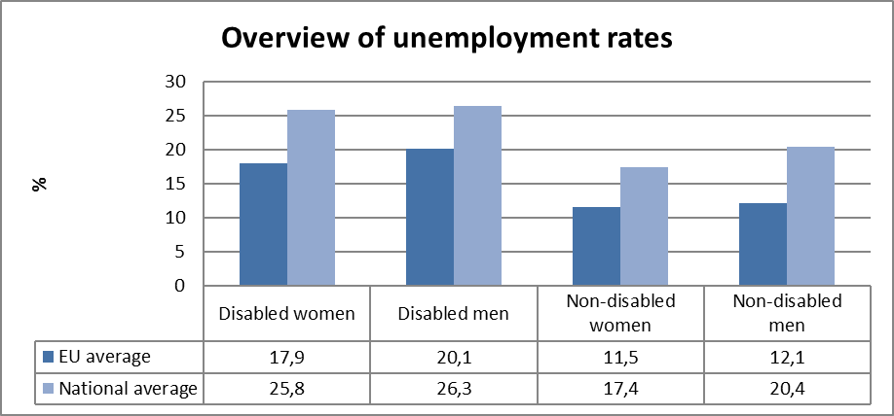
Source: EUSILC UDB 2013 – version 2 of August 2015

Table 7: Unemployment rate data, by age group
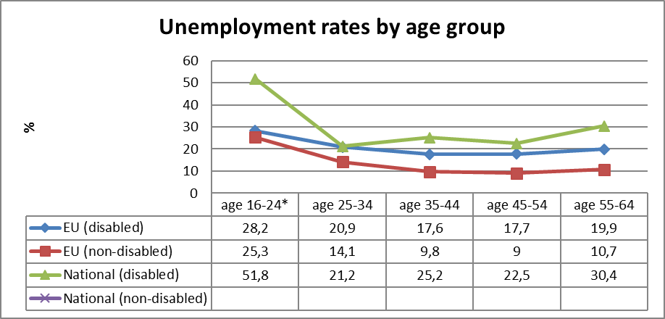
Source: EUSILC UDB 2013 – version 2 of August 2015
* In Bulgaria, there are fewer than 50 observations in the sample of people aged 16-24 who declare impairment/limitation. These data should be treated with caution.

Table 8: Trends in unemployment by gender and disability (aged 20-64)
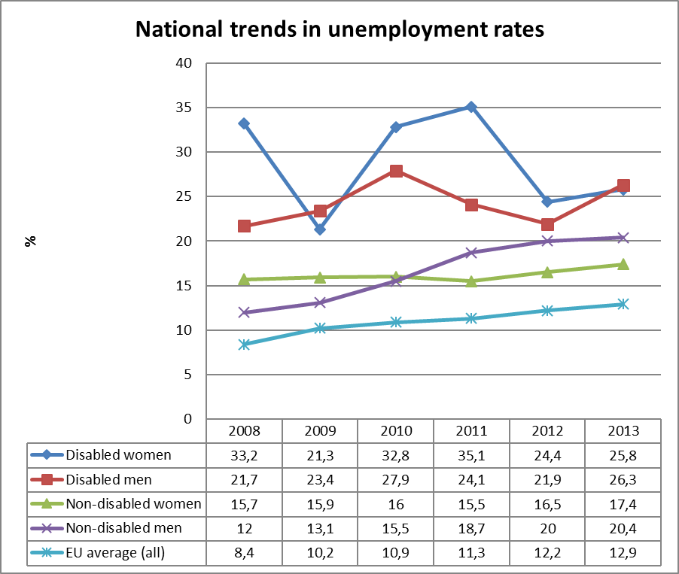
Source: EUSILC UDB 2013 – version 2 of August 2015 (and preceding UDBs)
Fluctuations in the gendered trends of unemployment for people with impairments at national level should be treated with caution.

Alternative data on disability and unemployment from national sources:

The 2014 Annual Review of the Employment Agency reports that the number of unemployed disabled people in 2014 is 17,346, which is an increase by 1,676 or by 10.7% compared to 2013. The share of this disadvantaged group in the labour market is reported to be growing from 4.2% in 2013 to 4.7% in 2014.

The National Social Security Institute (NSSI), which is responsible for handling disability pensions, reports the number of disability pensions’ beneficiaries being 434.596. It does not provide disaggregated data by age, gender or severity of the impairment. In previous years, however, the largest number of disability pensions – almost 50 percent – fell into the pre-retirement age group (55 – 64). Even so, the calculation of the share of unemployed disabled people at work age – 1.9 per cent – does not seem to reflect the real employment situation of the disabled people.

It is necessary to remind here that the Social Security Code defines unemployed people as ‘those registered with the Employment Agency Offices’ (Art. 54a, para 1). People with a disability status due to more than 50% lost capacity to work are granted disability pension and acquire retirement status thus being excluded from the labour force, respectively from the unemployment statistics. Those with severe impairments (over 90% lost capacity to work) do not even bother to register with the Employment Agency Offices. Thus a large portion of disabled people – as disability pensioners – remain unaccounted for as unemployed. In many cases their disability status (over 90 percent lost ability to work) does not allow employment at all. In addition, disabled people in institutional care, who receive pensions due to impairment – regardless of their age – are not considered at all in the labour force statistics.

Economic activity

Table 9: Most recent economic activity data, aged 20-64
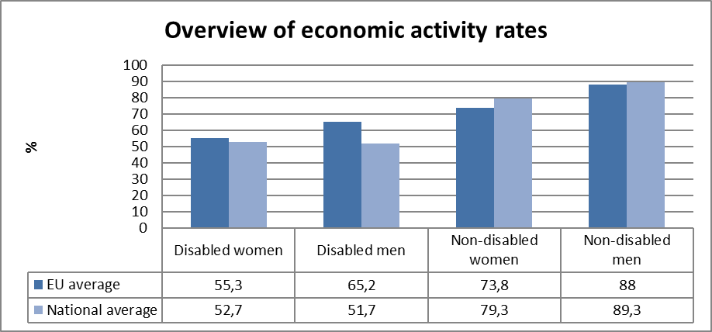
Source: EUSILC UDB 2013 – version 2 of August 2015

Table 10: Activity rate data, by age group
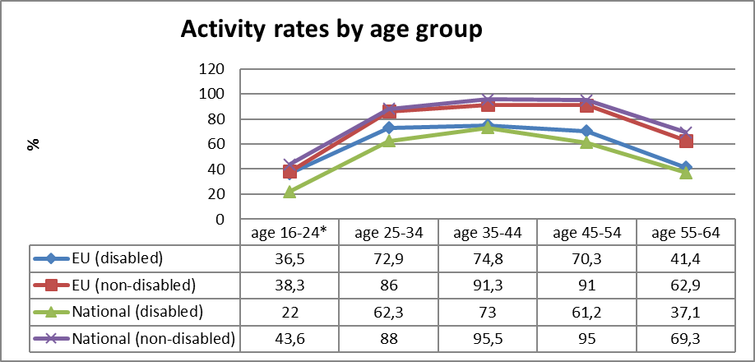
Source: EUSILC UDB 2013 – version 2 of August 2015
* in Bulgaria there are fewer than 50 observations in the sample of people aged 16-24 who declare impairment/limitation. These data should be treated with caution.

Table 11: Trends in activity rates by gender and disability (aged 20-64)
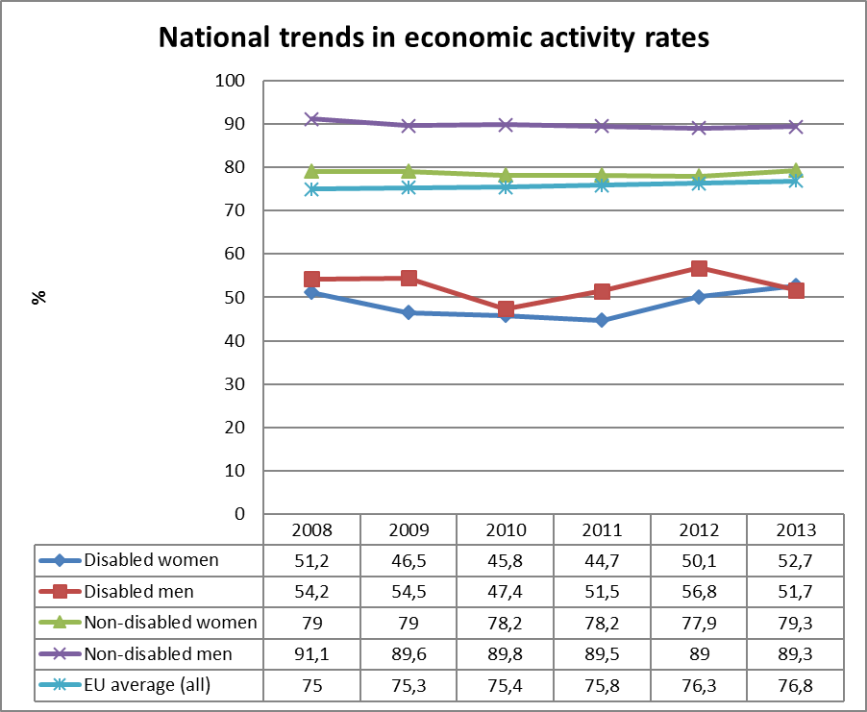
Source: EUSILC UDB 2013 – version 2 of August 2015 (and preceding UDBs)
Alternative data on disability and economic activity provided by the national expert:

There is no new data on disability and economic activity except for the National Statistics Institute (NSI) report on the National Census and Labour Force Survey performed in 2011. Numbers differ significantly but show similar situation of low economic activity of the disabled population. The number of economically active disabled people in 2011 is 67,549, which is almost 15% of the total number of disabled people (as reported in the Census, namely 461,000). The rate of economic activity among non-disabled people is 69.3%. The number of disabled people who are not economically active is 393,451 or 84.6% of all disabled people above 16 years of age. The share of retired disabled people is 95.5% or 377,222 in number – they are not necessarily above 64 years of age but having a disability pension fall into the social group of “pensioners”.

Education data

EU statistical comparisons are more limited concerning the education of young disabled women and men in the EU2020 target age groups. Data is available from EU-SILC (annually) as well as the Eurostat Labour Force Survey ad-hoc disability module (for 2011), but with low reliability for several countries on the key measures. Using a wider age range can improve reliability but estimations by gender remain indicative. EU trends are evident but administrative data may offer more reliable alternatives to identify national trends, where available.

Early school leavers

The EU-SILC sample for the target age group (aged 18-24) includes the following number of people reporting activity ‘limitation’ (as a proxy for impairment/disability).

Table 12: EU-SILC sample size in the target age group 18-24 versus 18-29
 | Age 18-24 |  | Age 18-29
 | No activity ‘limitation’ | Activity ‘limitation’ | No activity ‘limitation’ | Activity ‘limitation’
EU sample | 34,413 | 2,728 | 56,461 | 4,916
National sample | 801 | (41)* | 1,320 | 64
Source: EUSILC UDB 2013 – version 2 of August 2015
*The low number in the sample means that the data should be treated with caution.
Table 13: Early school leavers aged 18-24 (indicative based on above sample size)
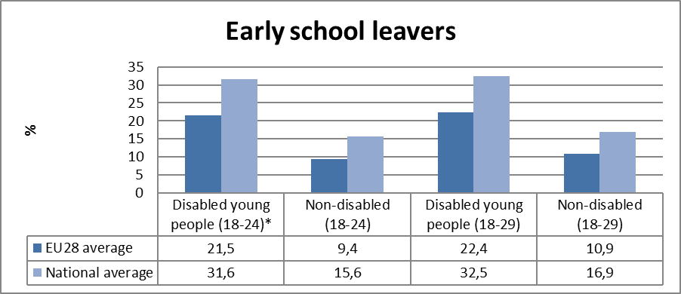
Source: EUSILC UDB 2013 – version 2 of August 2015
* In Bulgaria there are fewer than 50 observations in the sample of people aged 18-24 who declare impairment/limitation. These data should be treated with caution.

Alternative data on disability and early school leavers provided by the national expert:

Relevant documents include the Strategy to Combat Early School Drop-outs (2013-2020) and the Interim Report on the Implementation of the Strategy to Combat Early School Drop-outs (2013-2020).

The NSI reports 17,794 early school leavers out of a 751,001 total number of school students for the country in 2013/14 school year, which is 2.4%. There is no official data for the number of those who are disabled.

It has to be pointed out that children with severe disabilities and those in institutional care are not covered by the educational statistics at all. They are reported in the administrative data of the social welfare systems – day-care centres, community services and residential care facilities.

The Employment Agency report however shows that 52.2% of the active disabled job-seekers have primary and lower than primary education; 57.9% do not have any professional qualifications.

Tertiary education

The EU-SILC sample for the target age group (aged 30-34) includes the following number of people reporting activity ‘limitation’ (a proxy for impairment/disability) although the number of missing observations is larger than the number of observations for activity limitation.

Table 14: EU-SILC sample size for the target age group 30-34 versus 30-39
 | Age 30-34 |  | Age 30-39
 | No activity ‘limitation’ | Activity ‘limitation’ | No activity ‘limitation’ | Activity ‘limitation’
EU sample | 23,851 | 2,866 | 50,496 | 6,732
National sample | 585 | 51 | 1,302 | 120
Source: EUSILC UDB 2013 – version 2 of August 2015

Table 15: Completion of tertiary or equivalent education (indicative based on above sample)
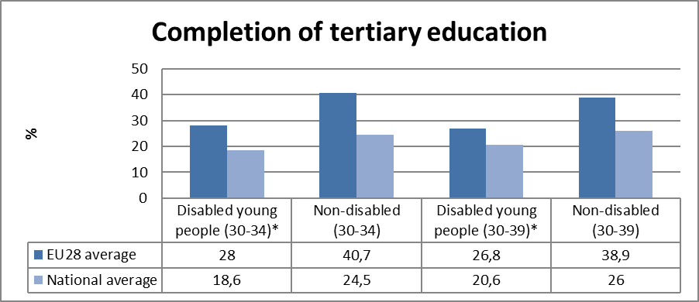
Source: EUSILC UDB 2013 – version 2 of August 2015

The survey sample is not sufficient to provide robust trend data disaggregated by gender in the narrow EU2020 target age group. In only 11 out of 28 Member States are there more than 50 observations in the sample for both women and for men in aged 30-34 who also declare impairment/limitation.

The following table is indicative at the EU level but gender trends at the national level should be treated with caution. In all Member States except Austria the achievement of tertiary education was higher for women than for men in both groups.

Table 16: Trends in tertiary education by disability (aged 30-34)
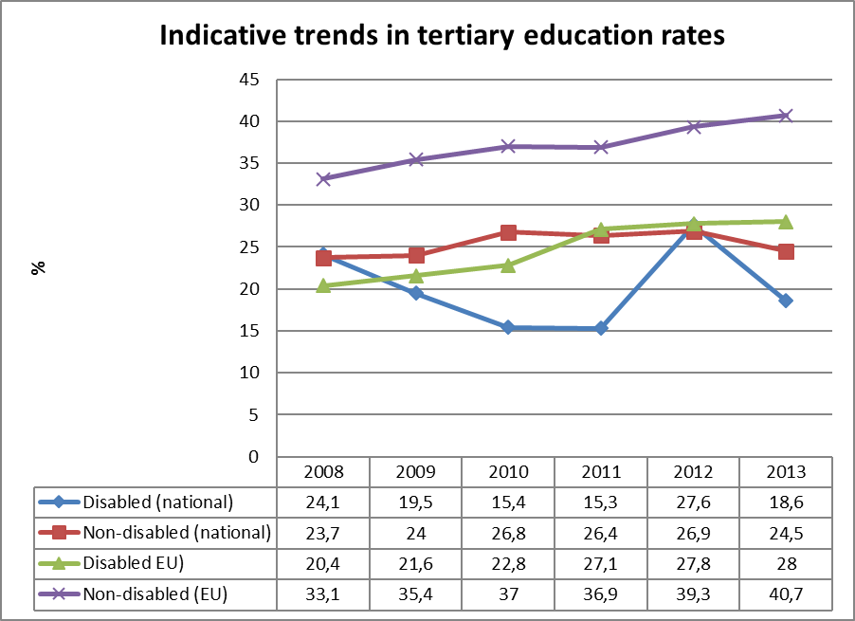
Source: EUSILC UDB 2013 – version 2 of August 2015 (and preceding UDBs)
Fluctuations in the trend for people with impairments at national level should be treated with some caution.

Alternative data on disability and tertiary education provided by the national expert:

NSI reports a 44.2% net rate of university enrolment for 2014/15. There is no official data on disabled university students.

Poverty and social exclusion data

EU SILC data provides indicators of the key risks for people with disabilities. In addition to household risks of low work intensity, there are risks of low income (after social transfers), and material deprivation. These three measures are combined in the overall estimate of risk. The risks for older people do not include work intensity (Eurostat refers to the age group 0-59 for this measure). The survey does not distinguish ‘activity limitation’ (the proxy for impairment/disability) for children under the age of 16. Relevant data provided by the national expert is added where available.

Table 17: People living in household poverty and exclusion by disability and risk (aged 16-59)
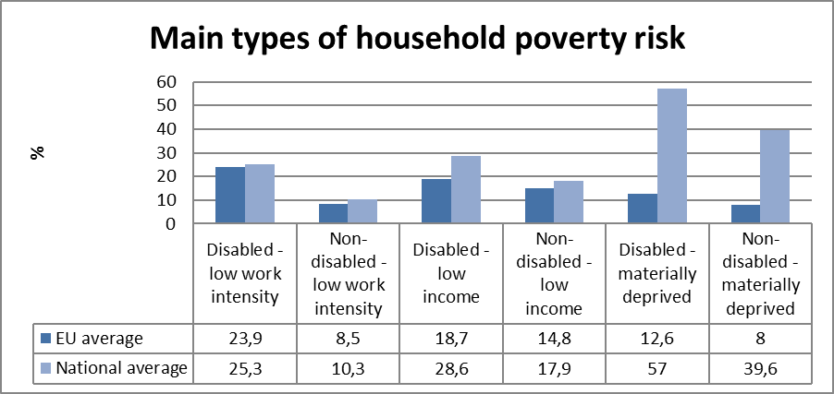
Source: EUSILC UDB 2013 – version 2 of August 2015

Table 18: People living in household poverty and exclusion by disability and gender (aged 16+)
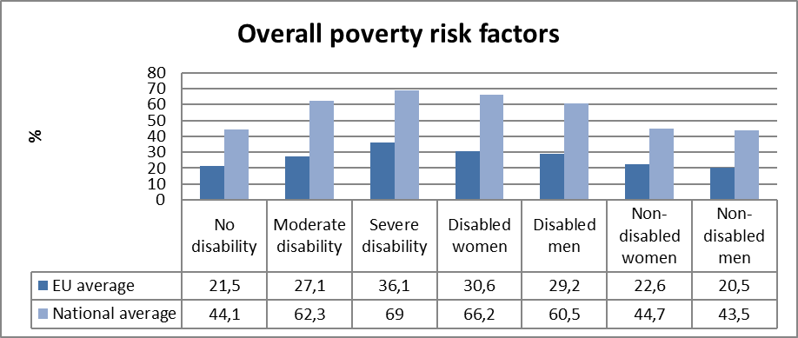
Source: EUSILC UDB 2013 – version 2 of August 2015

Table 19: Overall risk of household poverty or exclusion by disability and age (aged 16+)
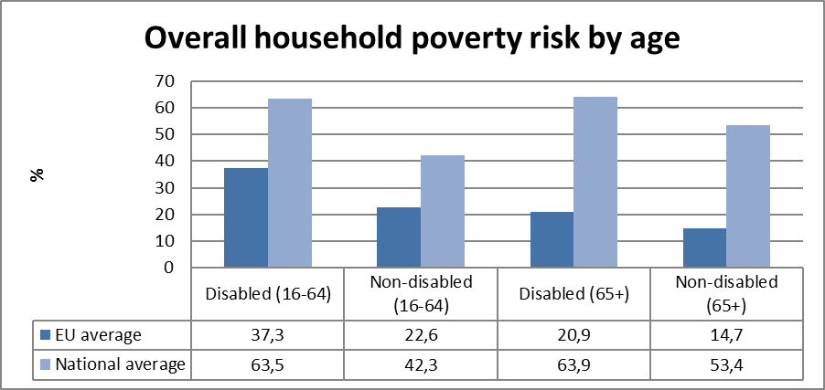
Source: EUSILC UDB 2013 – version 2 of August 2015

Table 20: Trends in household risk of poverty and exclusion by disability and age (EU-SILC 2013)
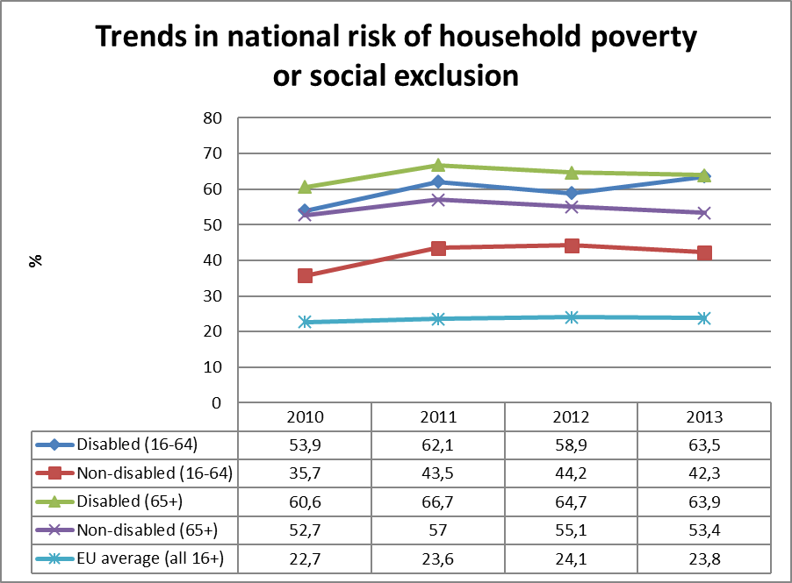
Source: EUSILC UDB 2013 – version 2 of August 2015 (and previous UDB)

Alternative data on disability and risk of poverty or social exclusion provided by the national expert:

The 2011-2020 Strategy on Employment of Disabled People adopted by the Council of Ministers on 29 June 2011 admits that “poverty levels among disabled people are by 70% higher compared to the non-disabled population due to the limited access to employment”. There is no other data on disability and poverty risks in official sources beyond the EU-SILC sample data.

Description of the situation and trends in relation to each target area

Employment

The conclusions of last year’s ANED report for Bulgaria are still valid, since the data on employment of disabled people continues to reflect people with disability status, which is granted on the basis of diagnosis causing ‘lost capacity to work’. Having said that, it is important to mention that the Government proclaimed “employment of disabled people” its first priority. The old fashioned way of placing disabled people into “retirement due to disability” is still in place disability thus making them beneficiaries of disability pensions regardless of the age and excluded from the unemployment statistics. People with complex support needs, i.e. disabled people due to barriers in the environment, as defined by the UN CRPD, though fully capable to work, are left out of the labour force and have no opportunities for employment due to the lack of individual employment related supports. Official government documents admit “limited access to employment” on the part of disabled people.

The approach to employment of disabled people continues to support employers failing to assist disabled people in their efforts to get and sustain a job – appropriate transport means, technical aids or personal assistance, not to mention the lack of accessible environment, which restricts their mobility in general. The results are limited to ‘subsidised employment’ for the duration of the grant scheme under the Human Resource Development Operational Programme. The major weakness of these schemes rests with their design, which provides for minimum monthly wage plus social security contributions paid by the Operational Programme to the employers hiring registered unemployed people with disability status ignoring individual needs of the disabled job applicants. It will be fair to say that the only beneficiaries of such schemes are people who do not encounter environmental barriers in their daily activities as well as the mainstream employers who gain access to labour force at no cost. A Chance for Everyone Scheme (BG051PO001-5.1.03) funded 8 projects submitted by private companes to hire disabled people and was worth BGN 0,841 mln (less than €0,5 mln). New Opportunities Scheme (BG051PO001-5.1.02) worth BGN 8.203 mln (over € 4 mln) resulted in 32 projects for 30 social enterprises, which reported employment of 744 people, including people with disability status. There are no monitoring or evaluation reports published yet.

Special enterprises and protected workshops continue to prevail the employment of people with disability status. In addition to the special treatment they enjoyed so far – tax relieves, rebates on social security contributions for rehabilitation of disabled workers, Government subsidies and State aid – amendments to the Public Procurement Act were made allowing for some tenders to be announced for special enterprises only. It was justified by the Government with the need to improve the financial situation of the disabled people by giving special enterprises access to the public procurement process (which, in fact, was never restricted). A look into the Register of the Agency for Disabled People shows that the total number of special enterprises registered since 2005 is 291, of which 169 have been registered just in the first ten months of 2015. This measure was criticised by the Institute for Market Economics but there was no response on the side of the Government.

Despite all these measures employment of disabled people remained at very low levels.

Education

The Bulgarian education system continues to maintain special schools, special classes within mainstream schools and individual education programmes (home teaching) for children with special educational needs. There is very limited body of research on inclusive education through accommodation of the needs of disabled children in mainstream schools. Centre for Inclusive Education reveals the flaws in the education system, showing the failure to qualify teachers properly, to provide teaching aids, to work with the entire school, etc.

Primary data from official sources is scarce and difficult to find. Information is usually shared at public events such as presentations by various officials, with no reference to the primary sources. Statements show that there is considerable progress towards inclusion of disabled children. However, parents of children with physical impairments went on TV showing barriers at school, which make them switch to “home teaching”, regulated by the law as “provision of individual education curriculum”. There are also cases of insufficient individual support in class for their disabled children. At the same time officials admit that barriers to employment of disabled people originate in their low education levels and lack of professional skills and experiences.

In 2015 the new School and Preschool Education Act was passed and will enter into force as of 1 August 2016 (para 60 of the Final Provisions). It provides for inclusion of disabled children in mainstream settings but the by-laws are still under development.

Poverty and social inclusion

Income of disabled people is primarily formed by (1) disability pension; (2) disability allowances, and in few cases (3) salary from employment. Most disabled people face unemployment (officials admit an around 90% unemployment rate among disabled people, see section 2.1.1), which leaves them with income from a disability pension and disability allowances, both being at very low levels. Every person with more than 50% lost capacity to work (based on his/her diagnosis) is entitled to have a disability pension, and NSSI report for 2012 reveals that social disability pensions have been paid to over 400,000 people at the level of €65 a month. ‘Disability pension for general health condition’ is paid to another 400,000 people and its size depends on the ‘years of work experience’ prior to getting the disability. People who have job-related income are still eligible for their disability pension. Both are provided at very low level, which is the reason why households of disabled people suffer material deprivation almost twice as much as those of non-disabled people, being exposed much more to a risk of poverty and social exclusion; the latter can be further explained by the lack of accessibility – of built environment, transport, public services, etc. Disabled people with over 90% lost capacity to work who need assistance in their daily activities are entitled to a personal aid supplement to the pension regardless of their individual needs, which currently amounts to BGN 90 (€45) per person.

A State-run Disability Integration Programme provides for monthly integration allowances to all disabled people with ‘more than 50% lost capacity to work’ depending on the type and level of disability, and regardless individual needs of the person, allowance for adjustment of living space, purchase and adaptation of a car, as well as for technical aids. Thus in 2014 the Social Assistance Agency reports ‘monthly disability integration allowances’ paid to 523 943 people (monthly average), for which almost BGN 137 mln. (€68 mln.) was spent giving each beneficiary less than BGN 22 per month. Another component of the Disability Integration Programme is the provision of technical aids, whose value in 2014 was estimated to BGN 41.2 mln (€21 mln.). The same document shows at the same time that only 4 disabled people were supported to buy and adjust a vehicle with an amount of BGN 1,200 (€600), and 5 were given support amounting to BGN 600 (€300) for adaptations in their living space; both provided on means-tested basis connecting the 12-months real income to the minimum secured income determined by the Government.

Poverty and social exclusion of disabled people are of structural and systemic nature, i.e. regardless of the public funds allocated for disabled people, they will remain poor and excluded because public policies and legislation do not deliver inclusive solutions in any major area of life.

This is the major reason for disabled people or their families to apply for institutional placements and to be admitted into residential care settings at a time when deinstitutionalisation is stated as a priority of the Government. Thus, social exclusion is sustained with the obvious poverty as a result of it, while huge amounts of public funds – both from national and EU sources – are spent.

Assessment of policies in place to meet the relevant headline targets

Employment

There is no evidence of political will to improve the disability employment rates despite the numerous measures listed in the 2015 NRP. This is because their design follows the traditional approach to disabilities imbedded in the current policies and measures, which support employers to hire people with disability status who do not necessarily encounter environmental barriers. There are also measures promoting active labour market policies, including support for self-employment. These measures, however, will not be effective unless the issues related to environmental barriers and individual supports are addressed.

Education

There is no evidence yet of reasonable and competent measures to be taken in order to reach the targets in the NRP. Enforcement regulations to the newly adopted legislation – School and Pre-School Education Act – are still to be developed.

Poverty and social inclusion

The National Reform Programme 2015 describes immense success in deinstitutionalisation and community based care, although this happens in violation of Art. 19 of UN CRPD – disabled people do not have a choice regarding where and with whom to live, how to live and perform daily activities. A financial standard per person in a service has been introduced and a ‘money follows the client’ approach has been made statutory, but only in residential care – no support for community living is provided for those who want to leave small group homes. Future plans refer to further ‘closure of large institutions’ and provision of ‘community-based care’ as framed so far. There are numerous reports revealing shortcomings in the deinstitutionalisation process recommending systemic changes, as for instance the independent review of the deinstitutionalisation process commissioned by UNICEF – Bulgaria. ENIL-ECCL Briefing on Structural Funds Investments for People with Disabilities report provided evidence that a lot of EU funds are spent on building new though small institutions or on repair works on the old ones, without providing for community living of disabled people.
Further on, the NRP refers to the National Strategy for Long-term Care, which is related to “independent dignified life of elderly people and people with disabilities”. The development of an Action Plan for the implementation of the strategy by 2015 is forthcoming. A new Law on Social Services will be developed in the period 2014 –2015 for the purpose of improving the system of provision and financing of social services, enhancing the planning and quality of services and developing systems for monitoring and control of the efficiency and effectiveness of the services provided.

It is unlikely to see improvement of the disabled people’ situation within the current policy framework, shaped by the medical model of disabilities. This will not allow Bulgaria to reach the EU targets in employment, education, poverty and social inclusion as far as disabled people are concerned – reaching the targets for the general population is likely to happen. Preserving the disability assessment related to the diagnosis without any consideration for the individual needs of the disabled person will keep people with extensive support needs out of employment, education and training, thus sustaining high poverty levels among this social group. There are no signs of any efforts planned to change mainstream systems and invest in their modernisation in a way that disability needs will be accommodated.

Synergies between developments in the different areas

Considering the current situation and available policy documents it is reasonable to say that disabled people – perceived as UN CRPD prescribes in its Preamble – will not enjoy positive changes unless disability policies are changed, which is not a commitment made by the decision makers in power. Measures addressing employment, education and poverty issues list disabled people as a target group but in the existing disability legislation, which defines disability as “lost capacity to work”. Pension reform deals with “early retirement” for different professional groups (police and army officers, for instance) and fails to address the heart of the problem related to disability pensions, namely the universal nature of the disability status granted with one single document issued by a medical panel and based on diagnosis alone. Once being granted disability status its holders enjoy all the benefits available, which are insufficient for people with profound needs and do not allow for independent living in the community.

Circumstantial evidence shows low levels of learning in school, which makes the transition to employment very difficult for disabled people, not to mention the efforts needed to sustain a decent job. There are no employment measures that address individual needs of the disabled people. Both existing and future programmes target mainstream and special employers encouraging them to hire disabled people.

Review of the European Semester from a disability perspective

Progress on disability-specific Country Specific Recommendations (CSRs)

COUNCIL RECOMMENDATION on the 2015 National Reform Programme of Bulgaria and delivering a Council opinion on the 2015 Convergence Programme of Bulgaria

Table 21: Policy measures related to achieving Recommendation #
Policy Measure
New School and Pre-School Education Act passed by the Bulgarian Parliament
Exact date of adoption
30th September 2015, entering into force as of September 2016
Budget allocation
-
Stage of implementation
By-laws under development
Is an independent evaluation planned?
n.a.
Assessment of impacts in relation to the CSRs
It is meant to address the issues of ineffective public education, low performance levels of the Bulgarian students, exclusion of vulnerable groups, including disabled children.
At the same time special schools have been preserved and there is no assurance, at this stage, that education of children with special educational needs will be financed enough to present itself as an alternative to special schooling for children with profound needs.
Ambition sufficient to meet CSRs?
At the level of political statements it seems relevant to meet CSRs. The implementation results are still to be seen. Centre for Inclusive Education shared concerns as to its possible effectiveness in terms of accommodating the educational needs of disabled children.
Credibility?
There were too many vested interests revealed at the drafting stage and the legislator allowed for lots of compromises. Results are still to be seen.

Progress on other CSRs from a disability perspective

The CSRs are focused on economic growth, financial sustainability, including the banking sector, education, employment and the labour market and judicial system. All CSRs could be given a disability perspective by allowing disabled people to operate in mainstream settings with the support needed by every individual. The newly adopted School and Pre-School Education Act has provisions on inclusion of children with special educational needs however its implementation will strongly depend on the by-laws, which are to be developed yet.
Employment of disabled people can be pursued through ear-marked resources for transport, professional training, coaching and personal assistance on the job based on individual needs assessment. This should be combined with continuing support for the employers to hire disabled people and close monitoring of the results both in numbers and in terms of quality of the job. These conclusions however are not in the CSRs.

Assessment of disability issues in the Country Report (CR)

The Bulgarian 2015 Country Report places disabled people in the general category of “vulnerable groups” along with Roma minority, youth and elderly. The section where disabled people are mentioned only once is on Labour Market Measures, Education and Social Protection (p. 54). “Key factors include an effective performance monitoring system and a fine-tuned targeting of the most vulnerable people, such as low-skilled and elderly workers, people with disabilities, the long-term unemployed and Roma people are important challenges.”, the report concludes.

There is no mention of accessibility of mainstream public services, individual supports or deinstitutionalisation process, all of which require revision and deep changes in order to comply with the UN CRPD provisions.

Assessment of the structural funds ESIF 2014-2020 or other relevant funds in relation to disability challenges

Bulgaria is still at the stage of absorbing EU Structural Funds for the 2007 – 2013 programming period. HRDP Priority Axes 4 and 5 have to do with disabilities and continue its implementation. Priority Axes 4 is related to education and training aiming at better access for vulnerable groups, including disabled children and adults. Its budget constitutes 16% of the total HRDP programme value, which is BGN380 mln (€190 mln). Areas of support include training of mainstream teachers, support for children with special educational needs, introduction of inclusive education methods, etc. Most of the projects are still in progress. It is not very likely to expect that inclusion of disabled children in school will be achieved because the educational system requires deep changes, which are not yet executed.

Priority Axes 5, Social Inclusion and Promotion of Social Entrepreneurship is the key financial instrument covering disability issues. Its budget represents 14% of the whole HRDP, which makes it over BGN 332 mln (€166.5 mln). Areas of interventions include support for the social economy, social services for prevention of social exclusion and enhanced working capacity through better health status. The responsibility for its implementation lies with the Social Assistance Agency.

More of the calls under this programme can hardly contribute to its main goal, namely: ‘… strengthening social inclusion’. For instance, beneficiaries under BG051PO001-5.1.03: Opportunities for All (worth BGN 20 mln. or €10 mln.) are special enterprises for disabled people only. It is clear that through support for segregated forms of employment no inclusion could be achieved. Calls BG051PO001-5.1.04: Home Help (worth BGN 30 mln. or €15 mln) and BG051PO001-5.2.09: Alternatives (worth BGN 35 mln. or € 18 mln.) are typical social services, which, firstly, should be provided by the Government, and secondly, on continuous basis. Being part of the operational programmes financed by the EU Structural Funds – not on as pilot or trial projects – shows that ESF money is used to cover costs, which should be made available for implementation of social policies by the Government as part of its Constitutional obligations. Home Help Project represents a modified classic service provided by municipal authorities for ages – now NGOs and companies could become service providers and compete with project applications for the money.

New Alternatives Programme (worth BGN 65 mln equal to €33 mln) is a continuation of the previous one called just Alternatives and followed by Alternatives – Phase 2 (worth BGN 13 mln equal to €6 mln; Budget Line: BG051РО001-5.2.16). Its overarching goal is to support independent living and social inclusion of disabled people. The objectives listed in the project document though relate to decentralisation in provision of personal assistants’ service and piloting ‘individual budgets for personal assistance’. It has been assigned to Social Assistance Agency (SAA) for implementation in cooperation with municipal authorities. The methodology of the service has been developed by the SAA and it defines the needs assessment procedure, imposes a limit of hours per month that a user can have, regulates working hours of the assistants (weekends and holidays are excluded!) and sets up the price per hour with reference to the minimum monthly wage for the country and a coefficient of 1,2 to 1,4 depending on the qualifications of the assistant. Beneficiaries were not allowed to use more than 160 hours per month. The latter restriction along with the low hourly rate makes it impossible for disabled people to hire assistants on the open labour market and most of the assistants are unemployed people referred to the disabled by the Employment Promotion Office or just relatives. The programme is still in progress but no official monitoring report is available yet. Thus all three calls re-enforce the status quo of dependency with more money spent.

BG051PO001-5.1.05: Empathy (worth BGN5 mln or €2,5 mln.) is reserved for nationally represented organisations of and for disabled people. There is no information on the developments and results.

De-institutionalisation (DI)

It is necessary to remind that resources from three operational programmes have been pulled into the process of DI in order to set up Family-type Residential Centres (FRC) as a priority followed by protected, monitored and other type of houses, all being similar and representing the generic form of small group homes (SMG) defined as ‘facilities for community based services’. ESF funding under Social Services for Social Inclusion (BG051PO001-5.2.06) worth BGN 23 015 000 (€12 mln.) is meant for ‘soft measures’ in community-based services, which boil down to institutional care within the urban areas of the cities. Living in the Community with a total value of BGN 30 mln. (€15 mln.) of which ESF contribution amounts to approximately €13 mln (85%), is another HRD OP budget line to help municipalities running residential services in the community such as monitored housing, protected housing, FRC, day-care centres, centres for social rehabilitation and integration.

In operational terms DI policies are implemented through the provisions of the Social Welfare Act (SWA) and its by-laws which define the menu of social services in residential settings and in the community that Bulgarian citizen are eligible for after an assessment of their individual needs. The list of community-based services includes: personal assistant (never offered on regular basis), social assistant, home attendant, home service, day-care centre, centre for social rehabilitation and integration. Centres for temporary placement, transition house, protected house and monitored house are in the category of ‘residential services provided in the community’. Management guidelines for these services are developed in a series of ‘methodologies’ – differences are hardly detectable, except for the name, number and qualification of the staff and the budget allocated for each ‘service’. Similarities though are obvious: they offer institutional type of placements for people with impairments.

Community services are activities delegated for implementation to municipal authorities by the National Government. They are funded by the national budget: a client at FRC is paid to the service provider BGN 8,800 (€4,490) (average) a year. This price at the monitored house is BGN 5,410 (€2,760) per year, a client placed in a protected house gives the provider BGN 7,224 (€3,686) per year, those who run a centre for social rehabilitation and integration receive BGN 2 600 (€1,326), whereas a day-care centre for disabled adults contributes to the service providers’ budgets BGN 6,392 (€ 3,261) per year. If a client decides to move out of the service no money follows the person in the community. Thus most of the residents and clients of services for disabled people are stuck with the service they use since most of the mainstream public services are not accessible for them and low level incomes do not allow them to pay for the services they need in the community.

In fact the whole process of deinstitutionalisation is deceptive representing a massive move of large cohorts of people from large residential facilities to small group homes with no difference in provision of care at all (see the case presented in the annex).

There is a petition filed with the European Parliament on lack of accessibility in public transport, including failure to comply with accessibility requirements when projects are implemented with financing from the EU Structural Funds.

The European Network on Independent Living (ENIL) reviewed the DI related use of Structural Funds in Central and Eastern Europe, in which Bulgaria is included as well. It shows the failure of the Bulgarian Government to provide for IL of disabled people and smooth transition from institutional care to community based services.

Recommendations

Disability Legislation for Social Inclusion

- New disability legislation needs to be developed as soon as possible in order to have the Bulgarian legal framework in line with UN CRPD, which will provide a sound basis for inclusive policies. Serious reforms are needed in the disability assessment procedures and granting disability status, denouncing the universal nature of one and only document issued by a panel of medical doctors. The Government should give serious consideration to the International Classification of Functioning, Disabilities and Health Individual (ICF) – a World Health Organisation approach to disability assessment – and incorporate it into the Bulgarian disability legislation. Eligibility factor in regard to disability benefits (pension, allowances, direct payments) and individual supports such as technical aids, accessible and affordable housing, personal assistance and peer support should be the result of the disability related needs assessment.
- Accessibility of the built environment remains to be an issue, though the legislation is in place. Monitoring of the existing and new constructions should be strengthened and made more effective. Urgent measures are needed to improve accessibility and inclusiveness of the mainstream public services – transport, education, healthcare, etc. – in order to accommodate the needs of disabled people.
- Deinstitutionalisation process should be revised and reformed in such way that to provide for real choices for the disabled people. Options for accessible and affordable housing should be created and personal assistance should be made available for all disabled people depending on their support needs. Funding for residential care should be organised in a way that to allow disabled people to choose whether they go for community living or stay in residential care. Such approach can lead to effective reduction of applications for residential placements, contribute to social inclusion and overcome poverty.
- Peer support and peer counselling are crucial for the positive outcome of the measures suggested in 7.3. Experiences of other countries show that peer support activities help disabled people to gain self-esteem and confidence that they can be the masters of their lives. ESIF could be used as a tool for funding peer support and exchange practices with other EU Member States on the subject.

Education and Employment

- Special schools should be closed and special disability training programmes should be cancelled and replaced by a requirement for disability accommodations in every mainstream teaching and training programme, which is financed by public funds – national or European. This will ensure acquisition of knowledge, skills and competences on the part of disabled people, which in turn will raise their compatibility on the labour market.
- Support for employers of disabled people should be balanced with personal supports for every disabled person on the basis of individual needs assessment for specific job performance. This approach should replace the current practice of opening special jobs for disabled people.

Statistical Data and Information

- Disability specific information should be collected by all line ministries in charge of the different areas of public life – health, education, employment, income and living conditions, transport, sports, culture, etc. This will show the extent to which the mainstream environment is adapted to accommodate the needs of disabled citizens.
- Line ministries should commission monitoring and evaluation of their policies from disability inclusion perspective in order to develop sectoral policies in inclusive manner.

Institutional Infrastructure for Social Inclusion of Disabled People

- The Agency for Disabled People needs to be strengthened and given more powers to shape and implement policies for social inclusion of disabled people. It should be the engaged in consulting other line ministries on their policies how to accommodate the needs of disabled people.
- It should be authorised to lead and be responsible for the provision of personal supports – such as disability allowances, technical aids and personal assistance, when introduced – in order to allow for different approach (individualised, human-rights based, result oriented, accounted for by the disabled beneficiaries) than the one applied to welfare allowances (at minimum, survival level, means tested and non-ear-marked for the beneficiaries).

http://ec.europa.eu/europe2020/pdf/targets_en.pdf.
EUSILC UDB 2013 – version 2 of August 2015.
The SILC survey questions are contained in the Minimum European Health Module (MEHM) http://epp.eurostat.ec.europa.eu/statistics_explained/index.php/Glossary:Minimum_European_Health_Module_(MEHM).
The methodology is further explained in the annual statistical reports of ANED, available at http://www.disability-europe.net/theme/statistical-indicators.
2014 Annual Review of the Employment Agency – http://www.az.government.bg/web/files/StatsFile/153/419/godishen-obzor-2014-g.pdf (last check on 17 October 2015).
Ibid – p.62.
Ibid.
Review of the Disability Pensions in the Years 2000 – 2014 http://www.noi.bg/images/bg/about/statisticsandanalysis/analysis/Analiz_pensii_Inv_2000-2014.pdf (last check on 17 October 2015).
Request under the Access to Public Information Act filed with the Ministry of Labour and Social Policy on 01st October 2015. Response not received. Case is currently in the Court of Justice.
Social Security Code of 2003, last amendments 13th October 2015: http://www.noi.bg/images/bg/legislation/Codes/KCO.pdf (last visited 27 October 2015).
Several court rulings have dealt with the “no right to work” ruling, which medical panels include in the final document granting disability status. It has been established by the Court that such statement is in violation of human rights.
National Census; NSI 2011, Disability Module: http://www.nsi.bg/sites/default/files/files/pressreleases/Census_Disability2011.pdf (last visited October 2015).
Employment of Disabled People – Additional Module to the Labour Force Survey 2011: http://www.nsi.bg/bg/content/4024/заетост-на-хората-с-увреждания-допълнителен-модул-към-наблюдението-на-работната-сила (last visited October 2015).
For the LFS AHM data see, Early school leavers http://appsso.eurostat.ec.europa.eu/nui/show.do?dataset=hlth_de010&lang=en and tertiary educational attainment http://appsso.eurostat.ec.europa.eu/nui/show.do?dataset=hlth_de020&lang=en.
http://minedu.government.bg/?h=downloadFile&fileId=6461.
http://minedu.government.bg/?h=downloadFile&fileId=8385.
NSI, Statistical Data on Early School Leavers: http://nsi.bg/bg/content/3435/%D1%83%D1%87%D0%B0%D1%89%D0%B8-%D0%B8-%D0%BD%D0%B0%D0%BF%D1%83%D1%81%D0%BD%D0%B0%D0%BB%D0%B8-%D0%BF%D0%BE-%D0%BF%D1%80%D0%B8%D1%87%D0%B8%D0%BD%D0%B8-%D0%B8-%D1%81%D1%82%D0%B5%D0%BF%D0%B5%D0%BD-%D0%BD%D0%B0-%D0%BE%D0%B1%D1%80%D0%B0%D0%B7%D0%BE%D0%B2%D0%B0%D0%BD%D0%B8%D0%B5 (last visited October 2015).
2014 Annual Review of the Employment Agency – http://www.az.government.bg/web/files/StatsFile/153/419/godishen-obzor-2014-g.pdf (last check on 17 October 2015).
NSI, Net Rate of University Enrolment for 2013/14 School Year http://www.nsi.bg/bg/content/3396/%D0%BD%D0%B5%D1%82%D0%B5%D0%BD-%D0%BA%D0%BE%D0%B5%D1%84%D0%B8%D1%86%D0%B8%D0%B5%D0%BD%D1%82-%D0%BD%D0%B0-%D0%B7%D0%B0%D0%BF%D0%B8%D1%81%D0%B2%D0%B0%D0%BD%D0%B5-%D0%BD%D0%B0-%D0%BD%D0%B0%D1%81%D0%B5%D0%BB%D0%B5%D0%BD%D0%B8%D0%B5%D1%82%D0%BE-%D0%BD%D0%B0-%D0%B2%D1%8A%D0%B7%D1%80%D0%B0%D1%81%D1%82-19-23-%D0%B3 (last visited 2015).
2011 – 2020 Strategy on Employment of Disabled People, Council of Ministers Record Nr 25.2 dated 29th June 2011: http://www.strategy.bg/StrategicDocuments/View.aspx?lang=bg-BG&Id=705 (last visited October 2015).
Ministry of Labour and Social Policy website on disabilities http://www.mlsp.government.bg/index.php?section=POLICIES&P=220 (last visited 15 October 2015).
2011 – 2020 Strategy on Employment of Disabled People, Council of Ministers Record Nr 25.2 dated 29th June 2011: http://www.strategy.bg/StrategicDocuments/View.aspx?lang=bg-BG&Id=705 (last visited 10 October 2015).
Special enterprises are regulated by ѝишл 28 до the Law on Integration of Disabled People. They are legal entities – in most if the cases private – registered under the Trade Act or the Law on Cooperatives, which report 30% of their employed staff to have disability status and have registration with the Agency for Disabled People. http://www.mlsp.government.bg/ckfinder/userfiles/files/politiki/hora%20s%20uvrejdania/normativni%20aktove/Zakon%20za%20integraciq%20na%20horata%20s%20uvrejdaniq.rtf (last visited 15 October 2015).
Agency for Disabled People Register – http://ahu.mlsp.government.bg/portal/se/ (last visited 30 October 2015).
Institute for Market Economics - http://ime.bg/bg/articles/horata-s-uvrejdaniya-instrument-za-peelene-na-obshtestveni-poryki/ (last visited 15 October 2015).
Centre for Inclusive Education, Research, 2015 - http://priobshti.se/category/izsledvaniya (last visited October 2015).
http://bnt.bg/news/obshtestvo/uchilishteto-nedosta-pno-za-detsa-v-neravnostojno-polozhenie – 09 June 2015.
http://news7.bg/predavania/oshte-neshto/vsichki-videa/imat-li-myasto-razlichnite-detsa-v-uchilishte/107867#.VpT6MGdulGp – 4 September 2015.
School and Pre-School Education Act - http://dv.parliament.bg/DVWeb/showMaterialDV.jsp?idMat=97877.
Art. 103 of the Social Security Code determines the size of the personal aid supplements at the level of 75% of the social pension for old age.
Social Assistance Agency report for 2014, p. 28 http://www.asp.government.bg/ASP_Files/APP/GODISHEN_OTCHET_ASP_2014.pdf (last check October 2015).
Ibid, p.29.
Art. 48 and Art. 50 of the Rules for Implementation of the Law on Integration of Disabled People (http://www.lex.bg/bg/laws/ldoc/2135497213 - last check in October 2015).
http://ec.europa.eu/europe2020/pdf/csr2015/nrp2015_bulgaria_en.pdf - last visit October 2015.
Ibid. Annex 1, items 3-4, p. 71 and 5-3, p. 117; http://www.minfin.bg/document/14328:11 - last check: February 2015.
Deinstitutionalisation of Children in Bulgaria - How Far and Whereto? Independent review of progress and challenges, 2014 - http://unicef.bg/en/article/DEINSTITUTIONALISATION-OF-CHILDREN-IN-BULGARIA-HOW-FAR-AND-WHERETO-Independent-review-of-progress-and-challenges/786 (last check on the 27 October 2014).
ENIL-ECCL Briefing on Structural Funds Investments for People with Disabilities, December 2013; http://www.enil.eu/recommended-readings-2/enil-eccl-briefing-on-structural-funds-investments-for-people-with-disabilities/ (last check on 27 October 2014).
NRP – 2014, p. 22 – 25; http://ec.europa.eu/europe2020/pdf/csr2014/nrp2014_bulgaria_en.pdf (last check on 27 October 2014).
http://ec.europa.eu/europe2020/pdf/csr2015/csr2015_bulgaria_en.pdf.
http://umispublic.government.bg/opOPProfileFinExec.aspx?op=1.
Ministry of Labour and Social Policy, Human Resource Development Programme - http://ophrd.government.bg/view_file.php/22070 - last visited October 2015.
Municipalities run the needs assessment process, contracting of assistants and payments of their salaries following a very detailed guidance of the Ministry of Labour and Social Policies.
Minimum monthly wage for 2015 was set up at the level of BGN 360 (€180) as of 1st January and BGN 380 (€190) as of 1st July - http://www.mlsp.government.bg/ckfinder/userfiles/files/TPOOUT/TPOOUT%3DNORMATIVE%20DOCUMENTS/Labour/Decrees/POSTANOVLENIE_139_na_MS_ot_4062015_g_za_opredelqne_novi_razmeri_na_minimalnata_rabotna_zaplata_za_st.doc - last visited October 2015.
http://ophrd.government.bg/view_doc.php/5037.
Social Welfare Act – http://www.lex.bg/bg/laws/ldoc/2134405633 - last visited October 2015.
Implementation Regulations to the Social Welfare Act – http://www.lex.bg/bg/laws/ldoc/-13038592 – last visited October 2015.
http://www.asp.government.bg/ASP_Client/ClientServlet?cmd=add_content&lng=1&sectid=13&s1=18&selid=18.
Regulation of the Council of Ministers dated 28th April 2015 - http://www.minfin.bg/document/17188:1 (last visit October 2015).
Petition 0312/2013 on behalf of the association ‘Center for independent living’, with 19 signatures, on the inaccessibility of public transport in Bulgaria for people with disabilities and persons with reduced mobility https://petiport.secure.europarl.europa.eu/petitions/en/petition/content/0312%252F2013/html/Petition-0312%252F2013by-Kapka-Panayotova-%2528Bulgarian%2529%252C-on-behalf-of-the-association-%25E2%2580%2598Center-for-independent-living%25E2%2580%2599%252C-with-19-signatures%252C-on-the-inaccessibility-of-public-transport-in-Bulgaria-for-people-with-disabilities-and-persons-with-reduced-mobility.
Briefing on the Use of Structural Funds to Support the Transition from Institutional Care to Community Living - http://www.enil.eu/news/briefing-on-the-use-of-european-structural-and-investment-fnds-to-support-the-transition-from-institutional-care-to-community-living-for-people-with-disabilities/ last visited October 2015.

